**LAB (6) Bug Report**

|  |  |  |  |  |  |
| --- | --- | --- | --- | --- | --- |
| Project Name: Youth loan management | | | Test Designed by: DEHAN,JASSY,ZERIN,NIBAL | | |
|  | | |  | | |
| Test Case ID: FR_1 | | | Test Designed date: 06/11/2022 | | |
|  | | |  | | |
| Test Priority (Low, Medium, High): HIGH | | | Test Executed by:  DEHAN,JASSY,ZERIN,NIBAL | | |
|  | | |  | | |
| Module Name: Login Session | | | Test Execution date: 06/11/2022 | | |
| Test Title: verify login with valid username and password | | | | | |
|  | | | | | |
| Description: Test website login page | | | | | |
|  | | | | | |
| Precondition (If any): User must have valid username and password | | | | | |
| Test Steps | Test Data | Expected Results | | Actual  Results | Status  (Pass/Fail) |
|  |  |  | |  |  |
| 1. Go to the website 2. Enter username 3. Enter password 4. Click submit | Username:  BLACKBOX  Password: 829 | User should login into the application | | As expected, | Pass |
|  | | | | | |
| Post Condition: User is validated with database and successfully login to account. The account session details are logged in the database. | | | | | |

|  |  |  |  |  |  |
| --- | --- | --- | --- | --- | --- |
| Project Name: Youth loan management | | | Test Designed by: DEHAN,JASSY,ZERIN,NIBAL | | |
|  | | |  | | |
| Test Case ID: FR_1 | | | Test Designed date: 06/11/2022 | | |
|  | | |  | | |
| Test Priority (Low, Medium, High): HIGH | | | Test Executed by:  DEHAN,JASSY,ZERIN,NIBAL | | |
|  | | |  | | |
| Module Name: LOAN PARTICIPATION | | | Test Execution date: 06/11/2022 | | |
| Test Title: Apply for loan with valid reason and age | | | | | |
|  | | | | | |
| Description: Test applications loan applying | | | | | |
|  | | | | | |
| Precondition (If any): User must have valid reason and age | | | | | |
| Test Steps | Test Data | Expected Results | | Actual  Results | Status  (Pass/Fail) |
|  |  |  | |  |  |
| 1. Go to apps main page 2. Enter valid reason 3. Enter valid age 4. Click submit | Valid reason:  Start up  Valid age: 22-30 | User should give valid reason and  age into the application | | As expected, | Pass |
|  | | | | | |
| Post Condition: User is validated with database and successfully apply for loan. The account session details are stored in the database. | | | | | |

|  |  |  |  |  |  |
| --- | --- | --- | --- | --- | --- |
| Project Name: Youth loan management | | | Test Designed by: DEHAN,JASSY,ZERIN,NIBAL | | |
|  | | |  | | |
| Test Case ID: FR_1 | | | Test Designed date: 06/11/2022 | | |
|  | | |  | | |
| Test Priority (Low, Medium, High): HIGH | | | Test Executed by:  DEHAN,JASSY,ZERIN,NIBAL | | |
|  | | |  | | |
| Module Name: Admin Login | | | Test Execution date: 06/11/2022 | | |
| Test Title: verify login with valid adminname and password | | | | | |
|  | | | | | |
| Description: Test website login page | | | | | |
|  | | | | | |
| Precondition (If any): User must have valid username and password | | | | | |
| Test Steps | Test Data | Expected Results | | Actual  Results | Status  (Pass/Fail) |
|  |  |  | |  |  |
| 1. Go to the website 2. Enter username 3. Enter password 4. Click submit | adminname:  BLACKBOX  Password: 829 | User should login into the application | | As expected, | Pass |
|  | | | | | |
| Post Condition: is validated with database and successfully login to account. The account session details are logged in the database. | | | | | |

**LAB (7)** **WBS**

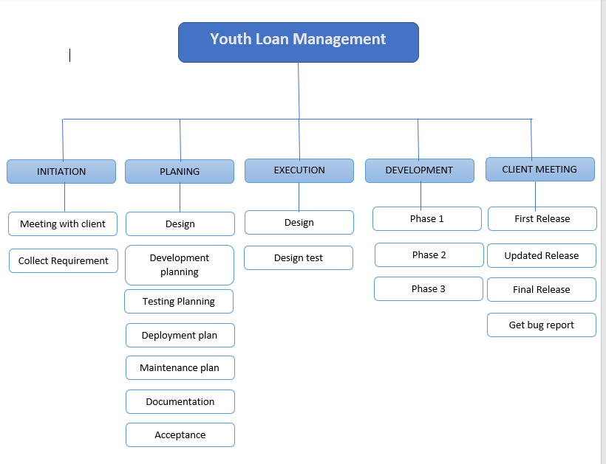

**Effort Estimation**

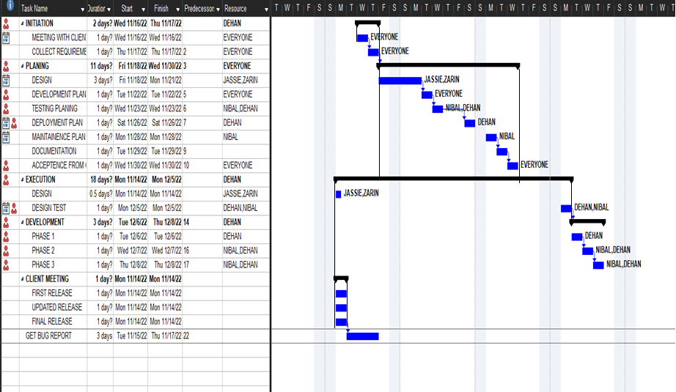

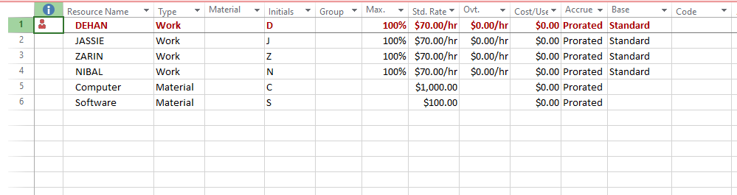**LAB (8)** **Resource Allocation**

**RESOURCE OVERVIEW**

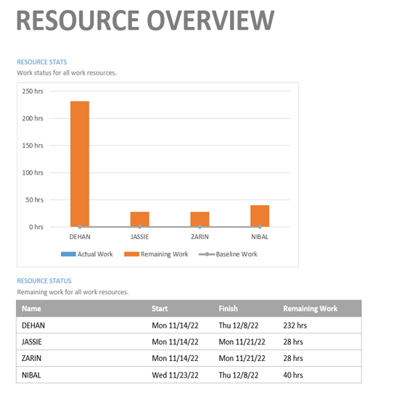

**Work done 100% after teams’ effort and participation.**

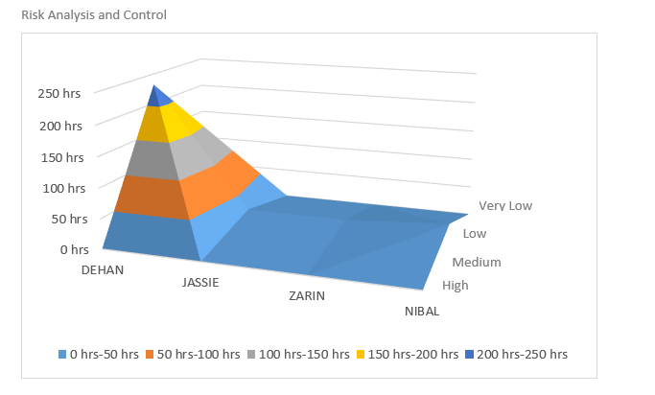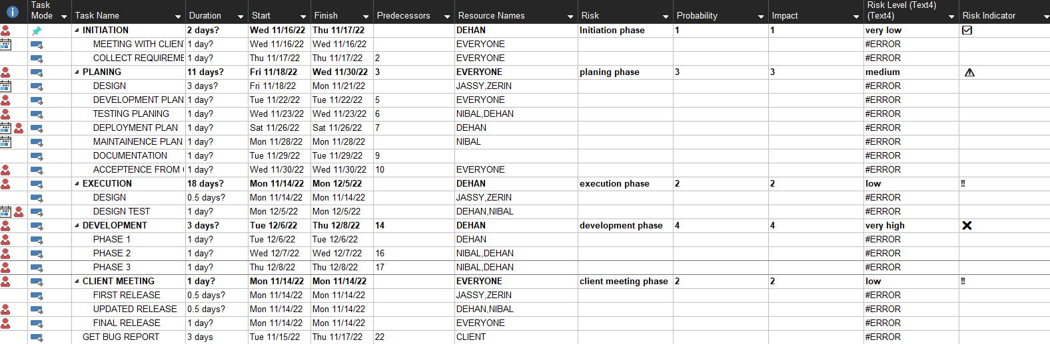**LAB (9)**  **Risk Analysis**